“The Final Battle Begins!!”

Galactic Finale!

<Logo Goes here>

*** Presented by ***
Michael Anthony Gonzalez

Contents
High Concept 2
Target Audience 2
Target Platform 2
ESRB Rating 2
Background Information 2
Objective/Goal 2
Gameplay 3
Game Controls 3
Art Specification 3
Audio Specifications 3
Technology and Licenses 3
Marketing 3
Team 4
Risk Analysis 4
Summary 4
Art Concepts 5

High Concept
In this space-shooter finale mini-game, take control of Platypus’s spaceship fighter as he escapes the Spaceship base and soars and battles through Asteroids and blobby aliens and their Leader to survive!

Target Audience
Galactic Finale! is playable for all ages, but is primarily targeted to an older audiences due to its mild violence.

Target Platform
Galactic Finale! will be targeting the personal computer operating system Windows™.

ESRB Rating
 Rated ‘E’ 10 and up. The game’s content does contain mild violence.

Background Information
Our hero escapes the spaceship by his spacecraft before the spaceship explodes. Once he makes his escape towards the asteroid belt, he encounters space blobby aliens in this battle frontier. The hero must use his spacecraft’s weapons and flight skills to evade and counter asteroids and enemies and make his way to the Leader of the Space Blobby Aliens to make his escape.

Objective/Goal
Players must pave his/her way through asteroids and aliens in order to reach the Leader of the blobby aliens to survive.

Gameplay
Galactic Finale! Is the 5th level of a multi-genre space adventure space shooter. Players will fly in the game space using a side scrolling view. The player will be able to shoot their obstacles and enemies and battle the Leader at the end of the game. Player will lose lives by contact by enemy fire and obstacles.

Game Controls
The player will use the Keyboard keys of directional arrow keys and WASD keys for 4 directional movements and the ‘B’ key to shoot energy bombs to destroy the enemies in front of player in an instance, and the Space key to shoot energy blast to obstacles and enemies.

Art Specification
Science fiction. Will have futuristic look, with a few frames of animation and low resolution sprites. Pixel art, with light and intense color pallet. Heavy geometric shapes and a few distinctive colors.

Audio Specifications
Galactic Finale! Will utilize high-tempo, intense techno music to set the intense tone making the player feel alert

Technology and Licenses
Galactic Finale will run on Unity, and the art and music will be from other artists.

Marketing
This game will be nostalgic to other space shooter games in the past. The game is but one part of a much larger whole, packed with a variety of features and gameplay. There is a variety of space shooter games in the market. Due to the limited development time I will have, the feature list is relatively small compared to other games like BattleStar Galactiga and several others.

Team
Michael Anthony Gonzalez: Programmer. He has been programming for roughly 2 years and knows some C++. He has created some games in Game Maker, and has little experience in Unity and Unreal engines.

Risk Analysis
Internal:
Strengths: multiple Computer backups in case of loss of game development losses or damages.
Weaknesses: there will be a very short development time frame for the project to complete.
External:
Strengths: The developer has a strong sense of aesthetics and meticulous sense of detail. Since there is only one developer on the project, the design will be entirely without compromise from his intent.
Weaknesses: There is only one developer on the project, so he will have to do every aspect of the game. This lack of external help combined with the lack of time may result in features being cut in order to meet ship date.

Summary
In this space shooter take mini game control of our hero as he maneuvers his way through asteroids and alien enemies to battle against the Leader of the Alien Blobbies to survive.

Art Concepts
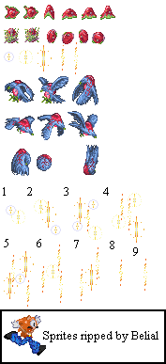
< http://www.spriters-resource.com/snes/psychodream/sheet/23957/ “aliens” by Belial >

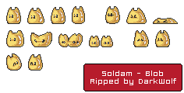
< http://www.spriters-resource.com/arcade/soldam/sheet/31316/ “Blob” by DarkWolf>
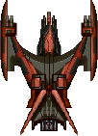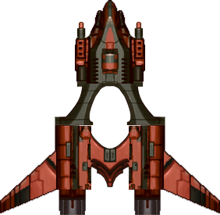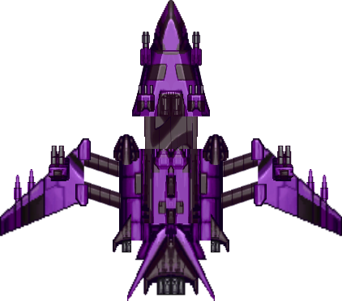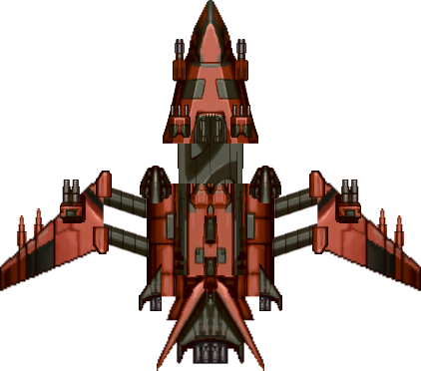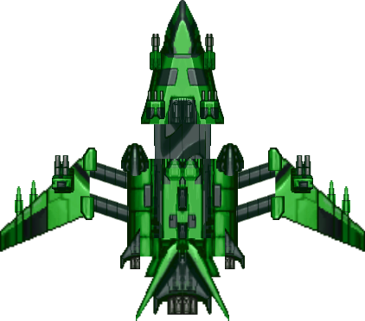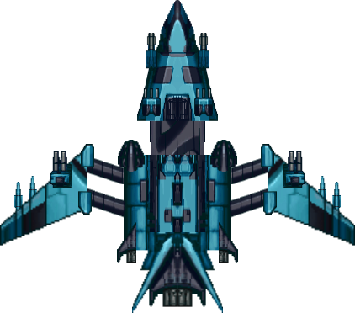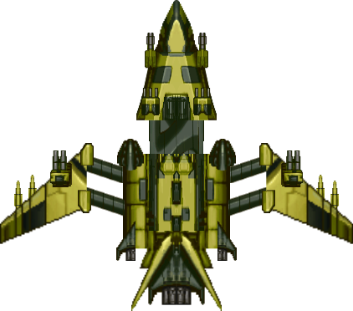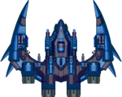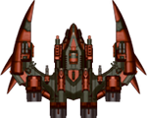
< http://opengameart.org/content/2d-spaceships-0 “Ships” by Skorpio >
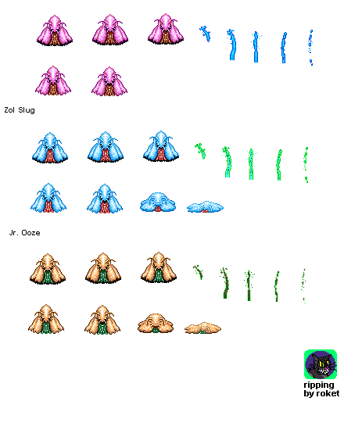
< http://www.spriters-resource.com/genesis_32x_scd/ps4/sheet/45213/ “Slugs” by Roket>
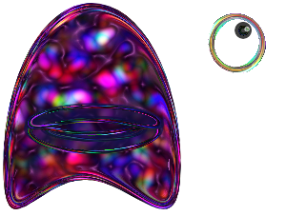
< http://opengameart.org/content/alien “Alien with no eyes” Author: JoshN >

